Post Incoming Payment with Down Payment - Normal

S.NO. : 02- FI-AR- 03

TRANSACTION CODE : F – 28

ACCESS PATH : SAP Easy Access Accounting Financial
Accounting Accounts Receivable Document
Entry Incoming payment Post

We get “ Post Incoming Payment” Header data” screen ;

Required Fields:

Document date : To be entered
Account : To be entered (Customer A/c Number)
Account Type : Default
Standard Ois : Default Ticked
Account : To be entered (Bank A/c Number)
Posting date : Default
Amount : To be entered (Diff Amt.)

Rest all other fields viz, Doc Type, Period, Companycode,Currency/Rate are default after they are entered for the first time.

We get the Screen “Post Incoming Payment - Header Data“ incorporating the above mentioned required fields as under;

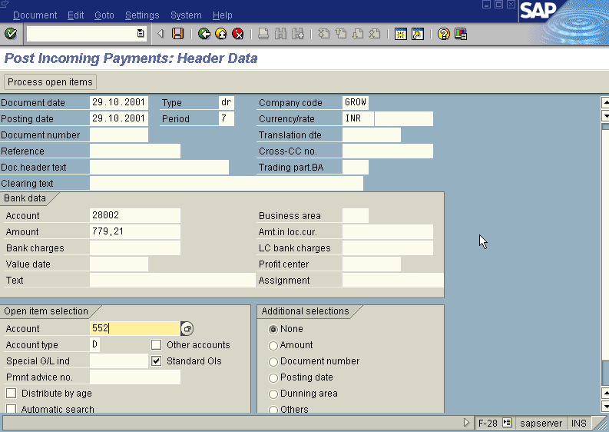

The point to be noted in the above “Post Incoming Payment - Header Data” screen is we have to leave the Spl. G/L Indicator field blank because we are clearing the Spl. G/L item down payment against the invoice.

Press button

Now we get “ Post Incoming Payment – Process Open Items” screen as below

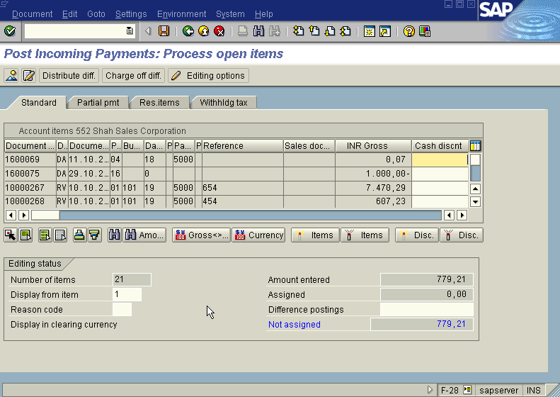

In the above “ Post Incoming Payment – Process Open Items” screen

Press icon (Select all) so that all items will be highlighted in blue.

Press icon (Deactivate items) so that all items will be highlighted in blue turns to normal in black

Now use the Scroll bar on the above “ Post Incoming Payment – Process Open Items” screen till we find the documents we wanted to post, Once found, Just just double click with the mouse on the Amount field.

Press Save button

The system will display a message as under

Take a note of the document number ; 18000109

This is the stage where “Post Incoming payment” stage is complete

The document can be seen from Document Display from the top left hand side of the main screen “post Incoming payment - Header Data“ OR from Transaction code FB- 03 .The Document overview screen will be displayed as under showing the entries.

